**LONG TERM INTERNSHIP**

**Team ID:** **LTVIP2026TMIDS77573**

**1.INTRODUCTION**

The rapid growth of digital technology and artificial intelligence has significantly transformed how people plan and experience travel. Modern travelers seek personalized, quick, and reliable travel recommendations without spending hours researching destinations, accommodations, and activities. Traditional travel planning methods often involve browsing multiple websites, reading reviews, comparing itineraries, and manually organizing plans, which can be time-consuming and overwhelming.

To address these challenges, the TravelGuideAI project leverages the power of Generative Artificial Intelligence to automate and personalize travel planning. This project focuses on developing an intelligent travel assistant capable of generating customized travel itineraries based on user inputs such as destination, number of days, and nights. By integrating Generative AI models, the system can produce human-like, context-aware travel plans that include attractions, daily schedules, and food suggestions.

This project demonstrates how AI can be used not only as a technical tool but as a practical solution to real-world problems. TravelGuideAI enhances user convenience, improves decision-making, and reduces planning effort. It represents the future of smart travel planning where AI acts as a virtual travel advisor.

**1.1 Project Overview**

TravelGuideAI is a Generative AI-based travel itinerary generator designed to help users create personalized travel plans quickly and efficiently. The application allows users to enter a destination and trip duration, and then automatically generates a structured itinerary with recommended places to visit, activities, and food suggestions.

The system is built using:

* Python for backend logic
* Streamlit for the user interface
* Google Gemini Generative AI API for AI-powered content generation
* Cloud-based AI services for scalable and intelligent responses

The application workflow is simple and user-friendly:

1. User enters travel details (destination, days, nights)
2. The system sends a structured prompt to the Generative AI model
3. The AI processes the request and generates a detailed itinerary
4. The itinerary is displayed in an organized format for the user

This project not only provides functional value but also serves as a learning platform for applying Generative AI in real-world scenarios. It demonstrates integration of APIs, prompt engineering, user interface design, and agile development practices.

TravelGuideAI is scalable and can be expanded in the future to include features such as hotel recommendations, budget planning, maps integration, and real-time weather insights.

**1.2 Purpose of the Project**

The primary purpose of the TravelGuideAI project is to simplify and enhance the travel planning experience using Generative AI. Many travelers struggle with planning due to lack of time, information overload, and difficulty in organizing schedules. This project aims to solve these issues by providing instant, personalized, and intelligent travel recommendations.

Key purposes include:

1️⃣ Simplify Travel Planning

Enable users to generate travel itineraries within seconds instead of hours of manual research.

2️⃣ Provide Personalization

Offer customized plans based on user inputs, making each itinerary unique and relevant.

3️⃣ Demonstrate Generative AI Capabilities

Showcase how modern AI models can generate meaningful, human-like content for practical applications.

4️⃣ Improve User Experience

Deliver a smooth and intuitive interface that requires minimal effort from users.

5️⃣ Academic & Skill Development

Serve as a hands-on project for learning:

* Generative AI integration
* API usage
* Prompt engineering
* Agile project management
* Software documentation and testing

6️⃣ Real-World Impact

Help travelers make better decisions, save time, and explore destinations more effectively

**2.IDEATION PHASE**

**2.1 Problem Statement**

Travel planning is an essential part of any trip, yet it remains a time-consuming and often stressful process for many people. Travelers typically spend hours researching destinations, browsing blogs, watching videos, comparing travel guides, and organizing daily schedules. This manual planning process can lead to information overload, confusion, and poorly structured itineraries.

Many existing travel platforms provide generic recommendations that do not fully match individual preferences, trip durations, or user needs. As a result, travelers may miss important attractions, waste time on inefficient schedules, or struggle to balance activities, food, and relaxation during their trip.

Additionally, not all travelers have prior knowledge about destinations, local culture, or must-visit places. First-time travelers, in particular, face difficulty in deciding what to prioritize within limited travel days. This creates a gap between available travel information and personalized travel planning.

With the rapid advancement of Artificial Intelligence, especially Generative AI, there is an opportunity to automate and personalize travel planning. However, many users still lack access to simple AI-powered tools that can instantly generate structured and customized itineraries.

Therefore, the core problem this project addresses is:

How can we simplify and personalize travel planning using Generative AI so that users can quickly generate reliable, customized itineraries without spending excessive time on research?

TravelGuideAI aims to solve this problem by providing an AI-powered travel itinerary generator that produces personalized, structured, and easy-to-follow travel plans based on user inputs such as destination and trip duration.

**2.2 Empathize Map**

The empathy map for TravelGuideAI was created to understand travelers’ behaviors, needs, and emotions during trip planning. The team analyzed how users search for travel information, what they expect from a planning tool, and what challenges they commonly face.

Travelers often want a smooth and enjoyable trip, but planning requires time, research, and decision-making. By mapping what users think, feel, say, and do, the team gained insights into their real needs and frustrations.

This empathy exercise helped the team view the problem from the traveler’s perspective. It guided the design of TravelGuideAI to ensure the solution is user-friendly, time-saving, and personalized.

Understanding the user deeply allows TravelGuideAI to deliver meaningful and practical travel itineraries.

Reference: <https://www.mural.co/templates/empathy-map-canvas>

**Empathy Map – TravelGuideAI**

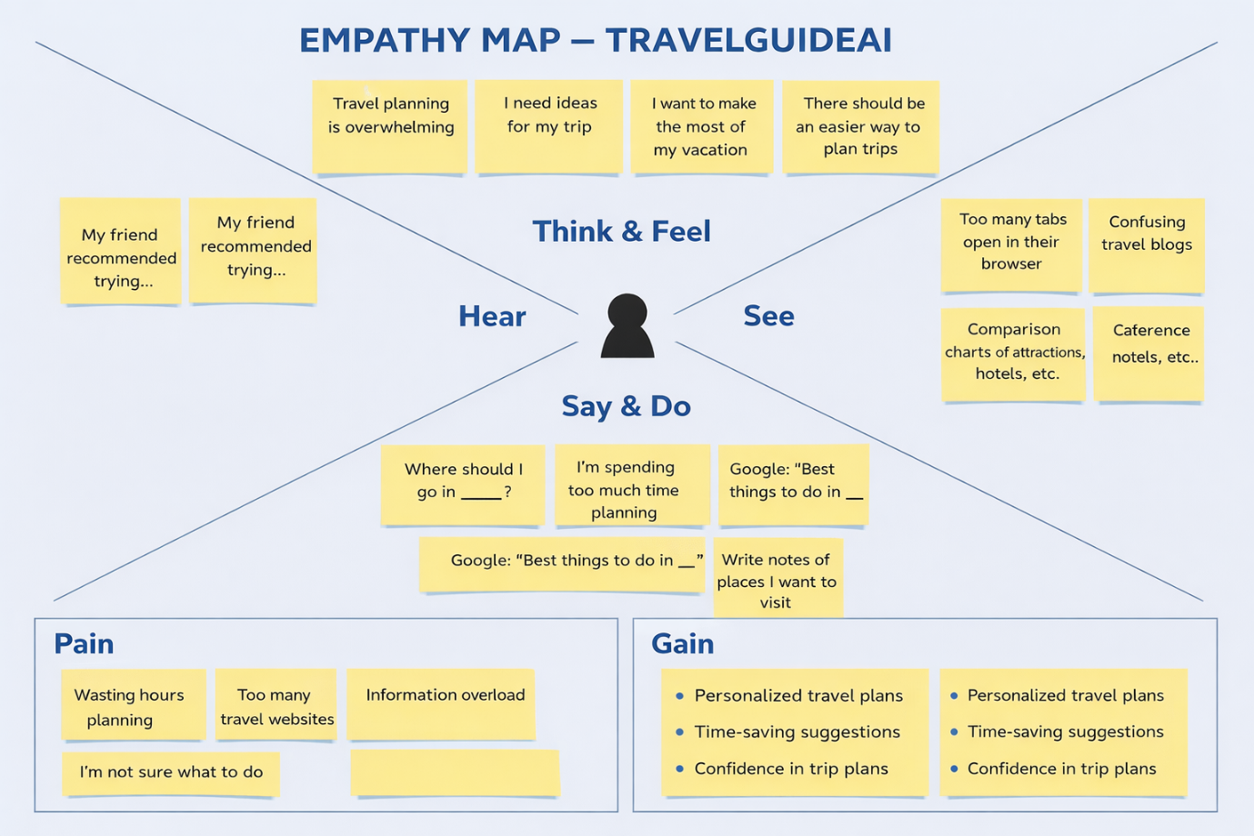

**2.3 Brainstorm & Idea Prioritization Template**

Brainstorming was conducted by the team to identify innovative project ideas suitable for a Generative AI internship. The objective was to explore real-world problems where AI could provide practical and scalable solutions. All team members actively contributed ideas related to AI, automation, and user convenience.

During the session, multiple ideas were discussed, evaluated, and expanded collaboratively. The team focused on selecting a project that demonstrates Generative AI capabilities, solves a real problem, and is feasible within the internship timeline.

Reference: <https://www.mural.co/templates/brainstorm-and-idea-prioritization>

**Step-1: Team Gathering, Collaboration and Select the Problem Statement**

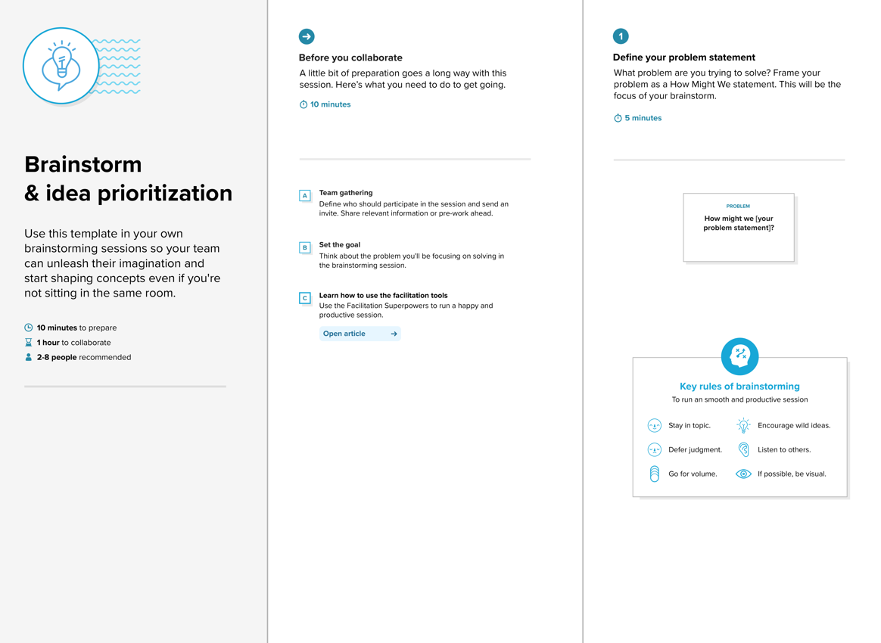

**Step-2: Brainstorm, Idea Listing and Grouping**

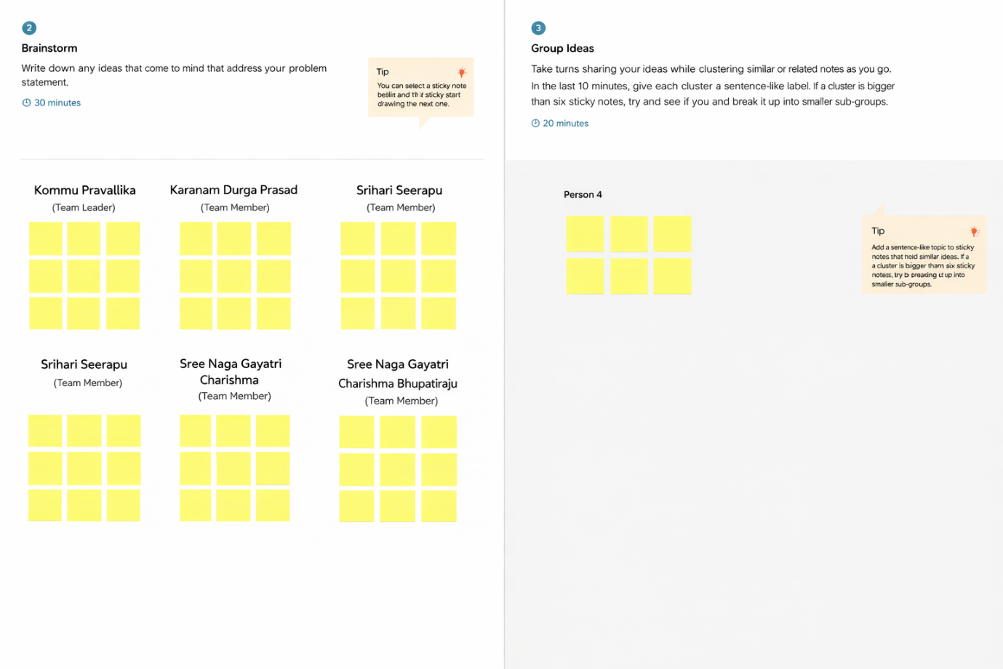

**Step-3: Idea Prioritization**

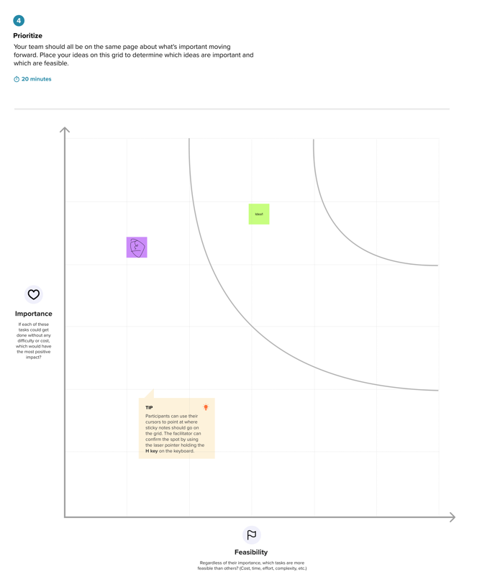

**3. REQUIREMENT ANALYSIS**

**3.1 Customer Journey map**

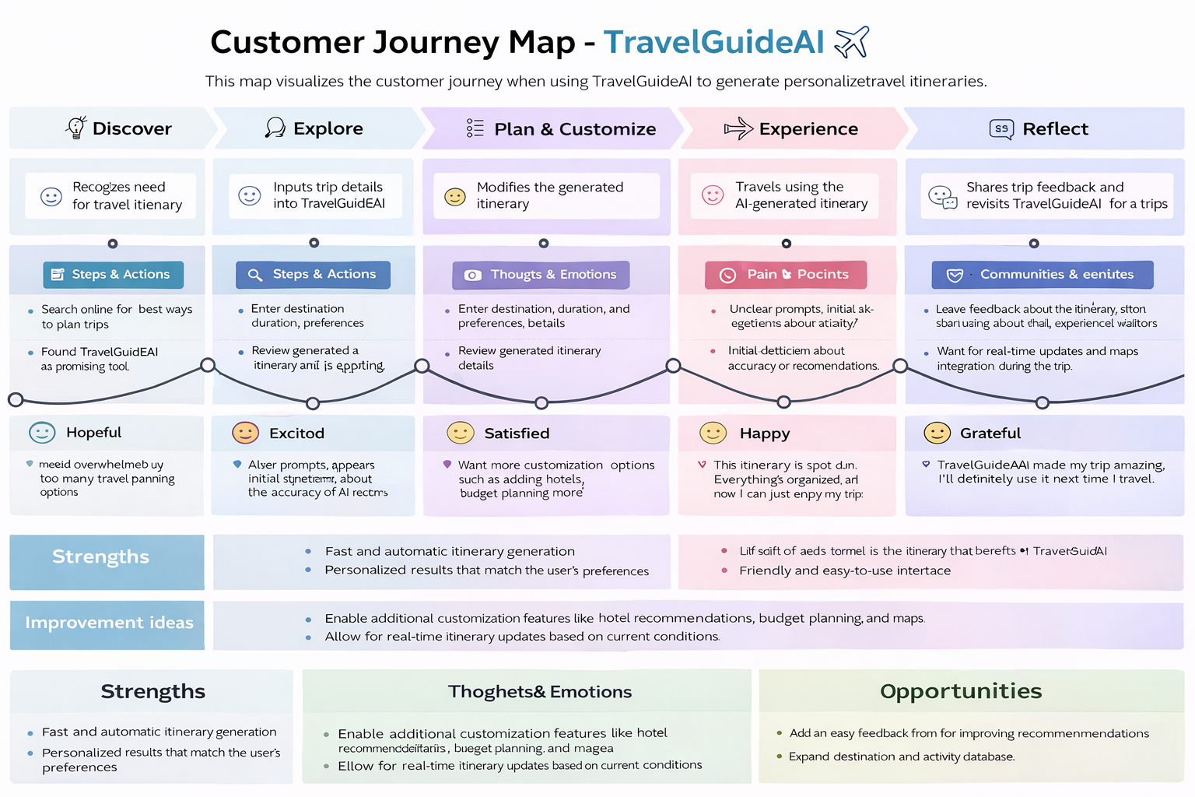

**3.2 Solution Requirements (Functional & Non-functional)**

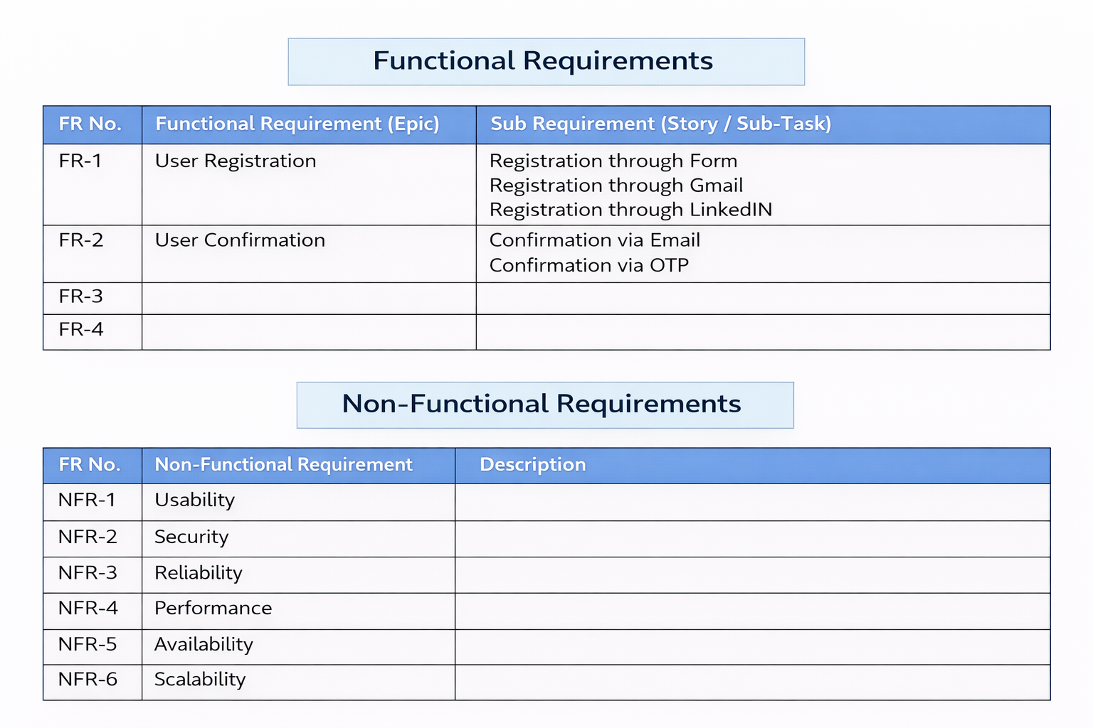

**3.3 Data Flow Diagram & User Stories**

The Data Flow Diagram (DFD) for TravelGuideAI illustrates how user inputs are processed to generate a personalized travel itinerary. The system is designed to capture user requirements, process them through a Generative AI model, and return structured travel recommendations.

In TravelGuideAI, the user provides inputs such as destination, number of days, and number of nights through the Streamlit interface. This data is sent to the backend system where it is formatted into a prompt for the Generative AI model.

The AI model processes the request and generates a detailed itinerary. The output is then sent back to the Streamlit application and displayed to the user.

The DFD helps visualize how information flows between the user, the application interface, and the AI model, ensuring a smooth and efficient itinerary generation process.

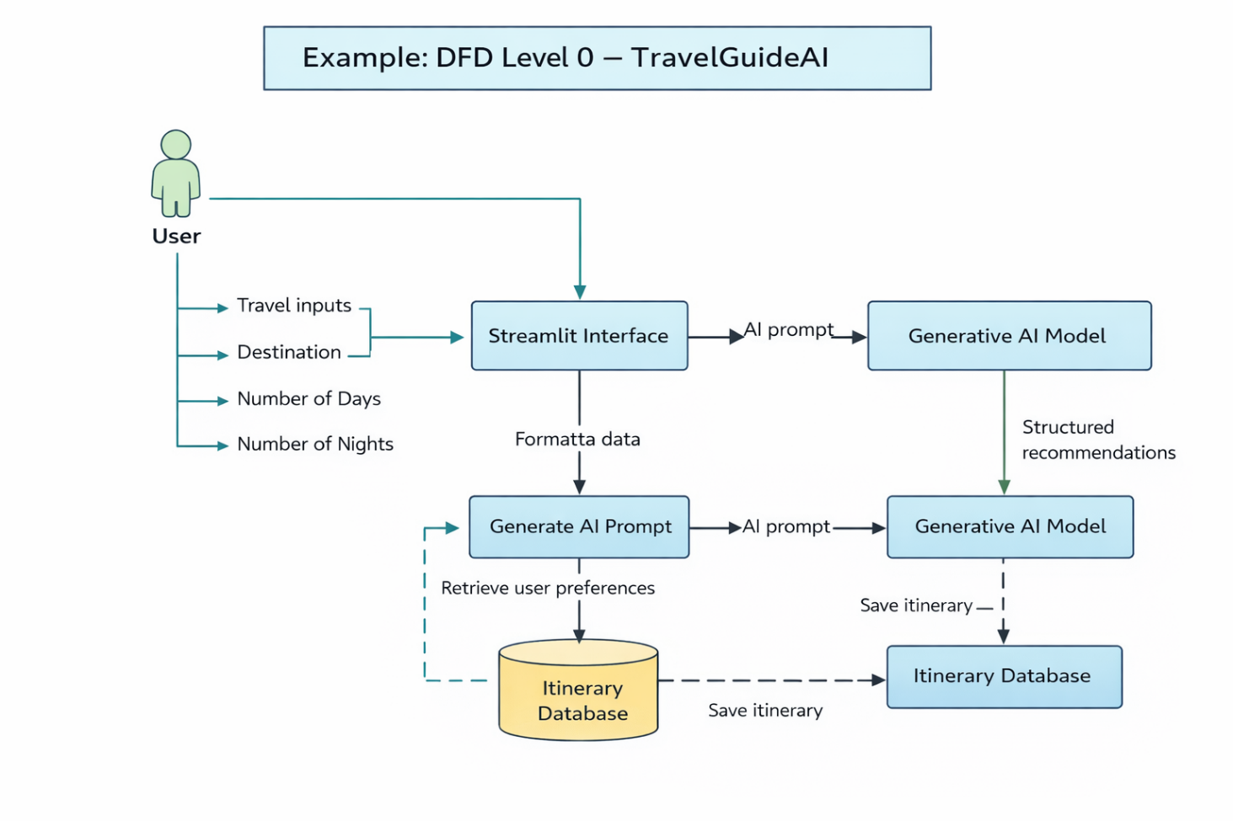

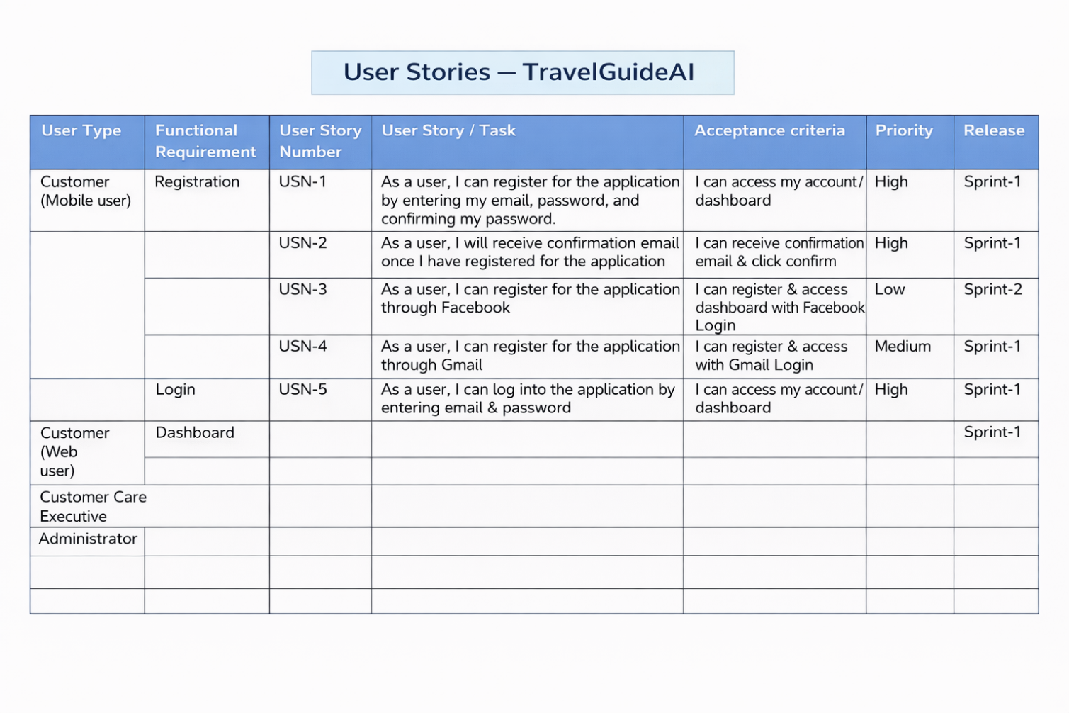

**3.4 Technology Stack (Architecture & Stack)**

**Technical Architecture:**

The Deliverable shall include the architectural diagram as below and the information as per the table1 & table 2

**Technical Architecture – TravelGuideAI**

The technical architecture of TravelGuideAI is designed to provide a smooth and intelligent travel itinerary generation experience. The system integrates a user-friendly frontend with a powerful Generative AI backend.

The architecture consists of three main layers:

**1️⃣ Frontend Layer (User Interface)**

The frontend is developed using **Streamlit**, which allows users to enter travel details such as destination, number of days, and number of nights. The interface is simple, interactive, and accessible through a web browser.

**2️⃣ Application Logic Layer**

This layer processes user inputs and formats them into structured prompts. It handles validation, request formatting, and communication between the frontend and the AI model.

**3️⃣ AI Processing Layer**

The Generative AI model (Gemini) analyzes the user’s inputs and generates a personalized travel itinerary. The model creates structured outputs including daily plans, attractions, and dining suggestions.

The generated itinerary is then sent back to the Streamlit interface for display to the user.

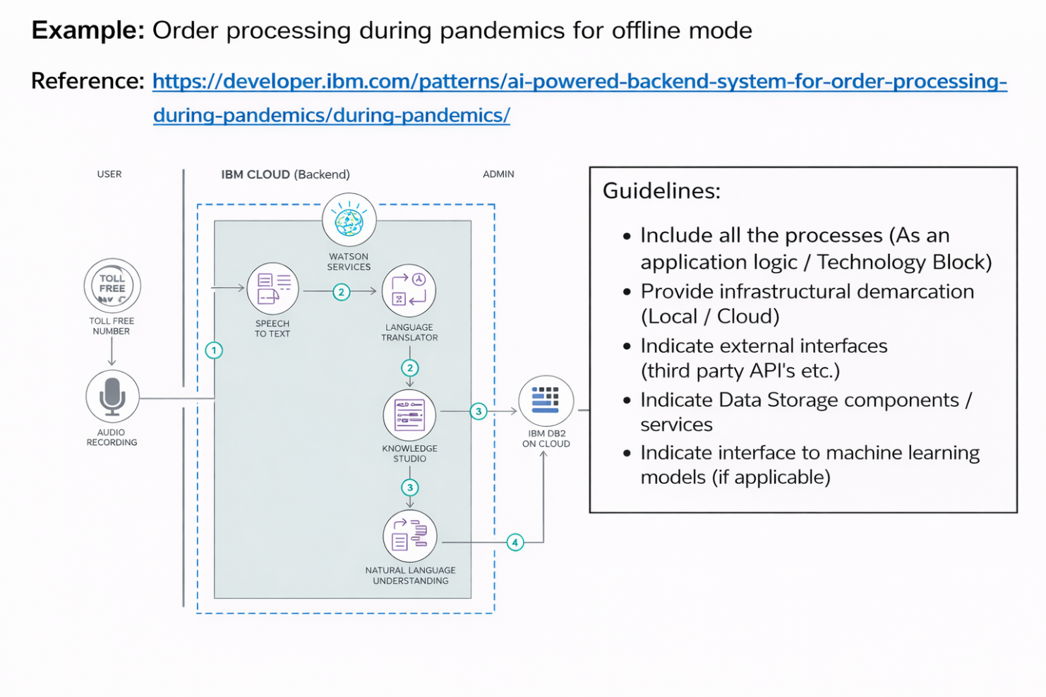

**Table-1 : Components & Technologies:**

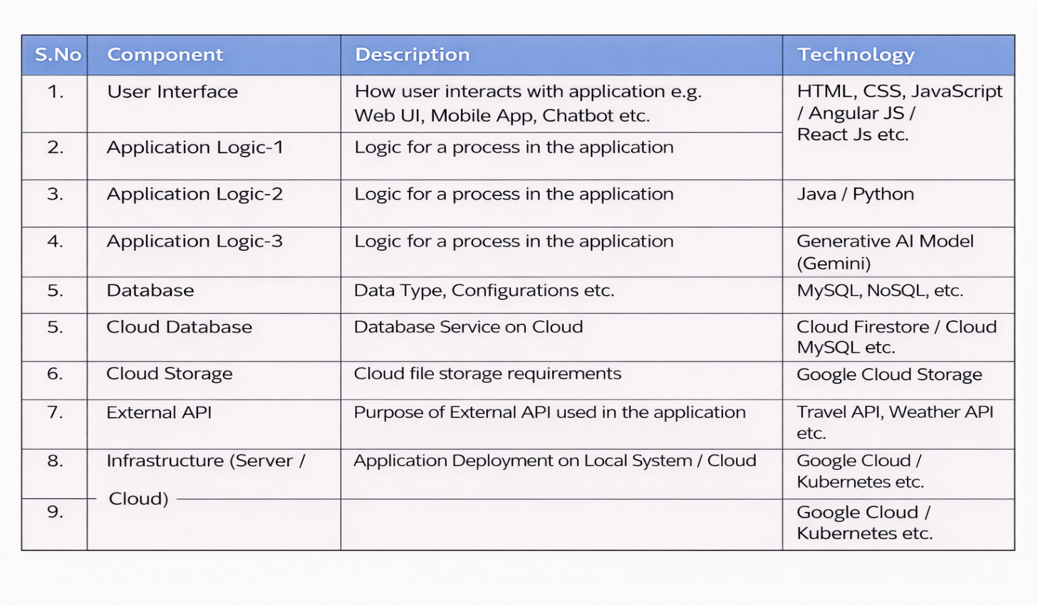

**Table-2: Application Characteristics:**

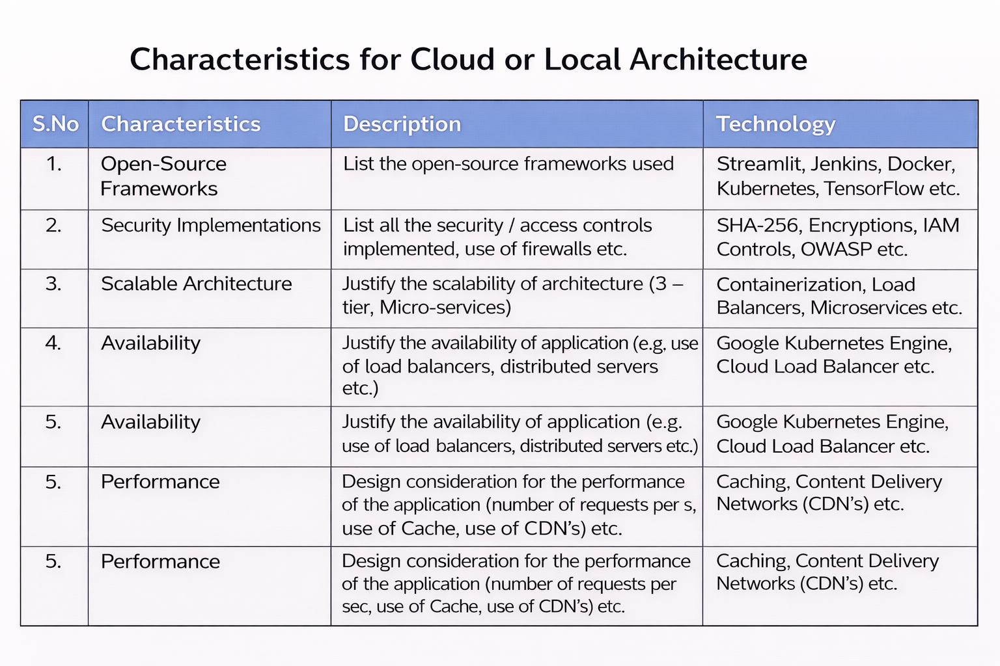

**References:**

[**https://c4model.com/**](https://c4model.com/)

[**https://developer.ibm.com/patterns/online-order-processing-system-during-pandemic/**](https://developer.ibm.com/patterns/online-order-processing-system-during-pandemic/)

[**https://www.ibm.com/cloud/architecture**](https://www.ibm.com/cloud/architecture)

[**https://aws.amazon.com/architecture**](https://aws.amazon.com/architecture)

[**https://medium.com/the-internal-startup/how-to-draw-useful-technical-architecture-diagrams-2d20c9fda90d**](https://medium.com/the-internal-startup/how-to-draw-useful-technical-architecture-diagrams-2d20c9fda90d)

**4. PROJECT DESIGN**

**4.1 Problem – Solution Fit Template**

**I**n the context of *TravelGuideAI* means identifying real travel planning difficulties faced by users and providing an AI-powered itinerary solution that genuinely solves those issues. It ensures that the system is not just innovative, but also practical, useful, and aligned with user needs.

TravelGuideAI focuses on simplifying trip planning by generating personalized travel itineraries based on user inputs like destination, number of days, and preferences. The solution fits the problem by reducing planning time, confusion, and information overload.

**Purpose**

✅Solve real travel planning challenges  
TravelGuideAI helps users who struggle with deciding where to go, what to do, and how to organize their trips efficiently.

✅ Improve solution adoption  
By providing instant AI-generated itineraries, users can quickly see value, increasing usage and trust in the platform.

✅ Enhance communication & engagement  
Clear recommendations, structured daily plans, and user-friendly design make the experience simple and engaging.

✅ Increase user touchpoints  
Frequent travelers can reuse the platform for multiple trips, creating continuous engagement and loyalty.

✅ Understand and improve user experience  
By analyzing user inputs and preferences, TravelGuideAI continuously provides more relevant and personalized suggestions.

**Template:**

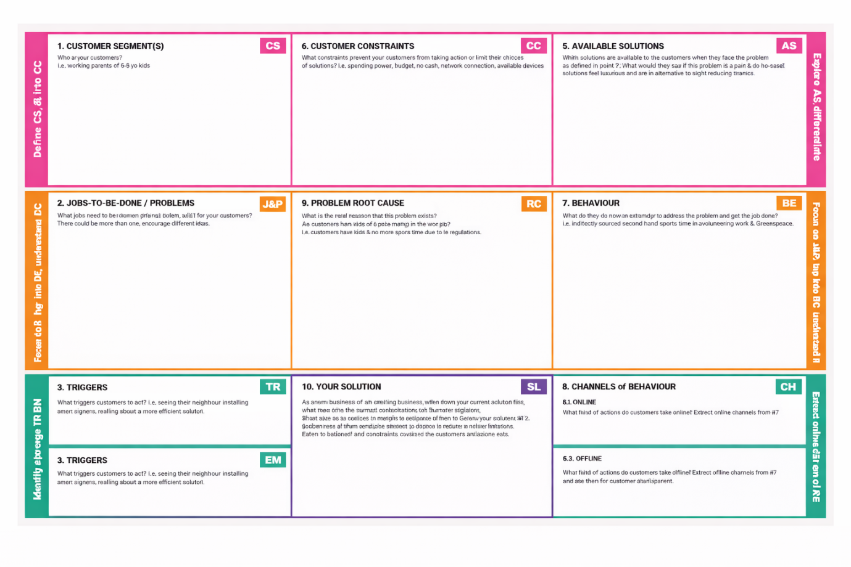

References:

1. <https://www.ideahackers.network/problem-solution-fit-canvas/>
2. <https://medium.com/@epicantus/problem-solution-fit-canvas-aa3dd59cb4fe>

**4.2 Proposed Solution Template**

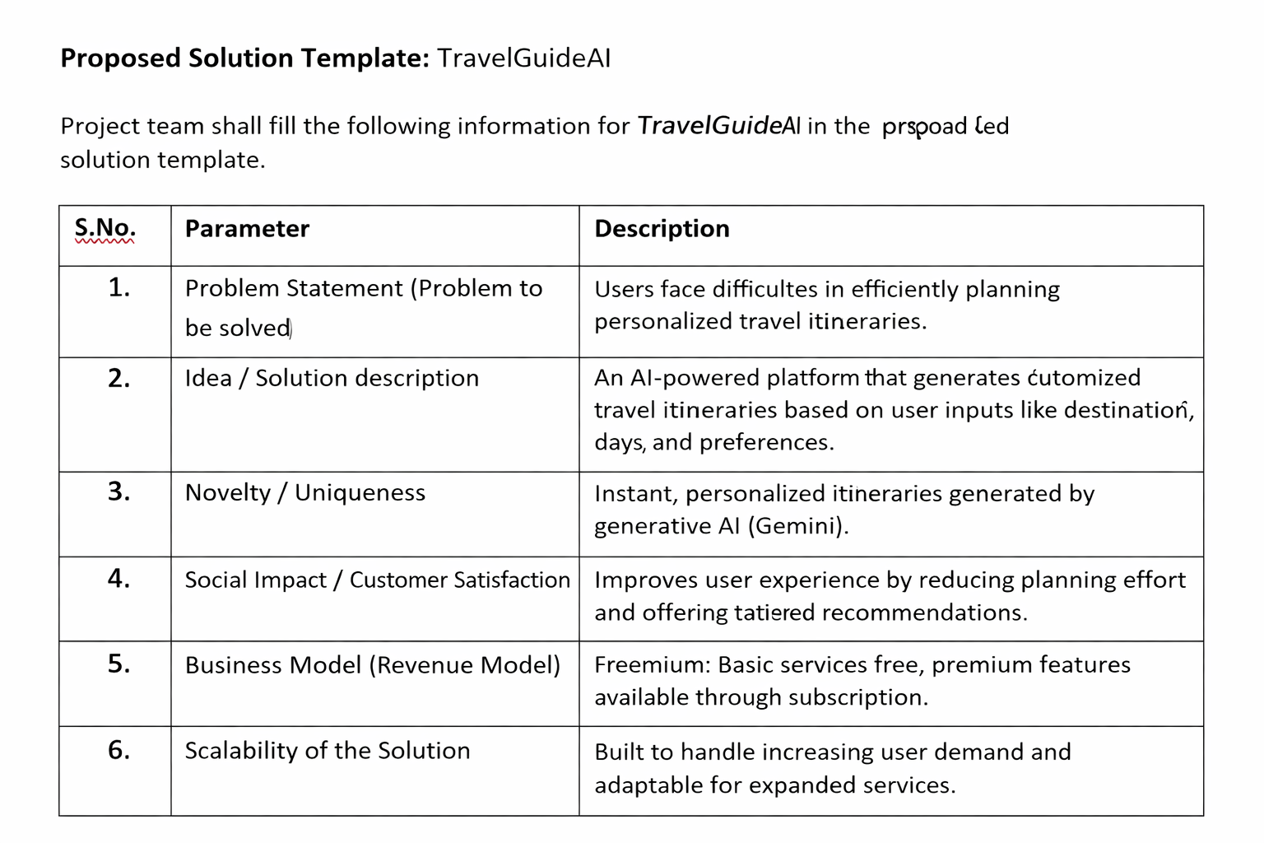

**4.3 Solution Architecture**

**Solution Architecture:**

Solution architecture for *TravelGuideAI* defines how the system converts user travel needs into intelligent, AI-generated itineraries. It connects user requirements, application logic, and generative AI services into a smooth, scalable system.

Goals of the TravelGuideAI Solution Architecture

● Deliver an AI-powered travel planning solution that generates personalized itineraries based on destination, days, and nights.

● Clearly define system structure and components (UI, backend, AI model, and APIs) so stakeholders understand how the system works.

● Outline features and development phases such as itinerary generation, user input handling, and result presentation.

● Specify technical requirements for deployment, API integration, and data handling.

● Ensure scalability and reliability so multiple users can generate itineraries simultaneously.

**Solution Architecture Diagram:**

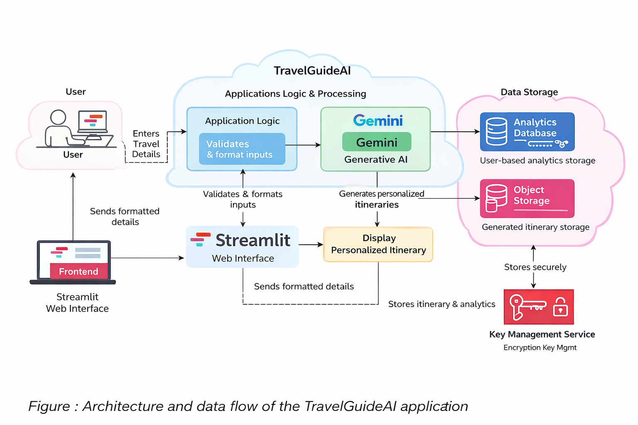

**Reference:** [**https://aws.amazon.com/blogs/industries/voice-applications-in-clinical-research-powered-by-ai-on-aws-part-1-architecture-and-design-considerations/**](https://aws.amazon.com/blogs/industries/voice-applications-in-clinical-research-powered-by-ai-on-aws-part-1-architecture-and-design-considerations/)

1. **PROJECT PLANNING & SCHEDULING**

**5.1 Project Planning**

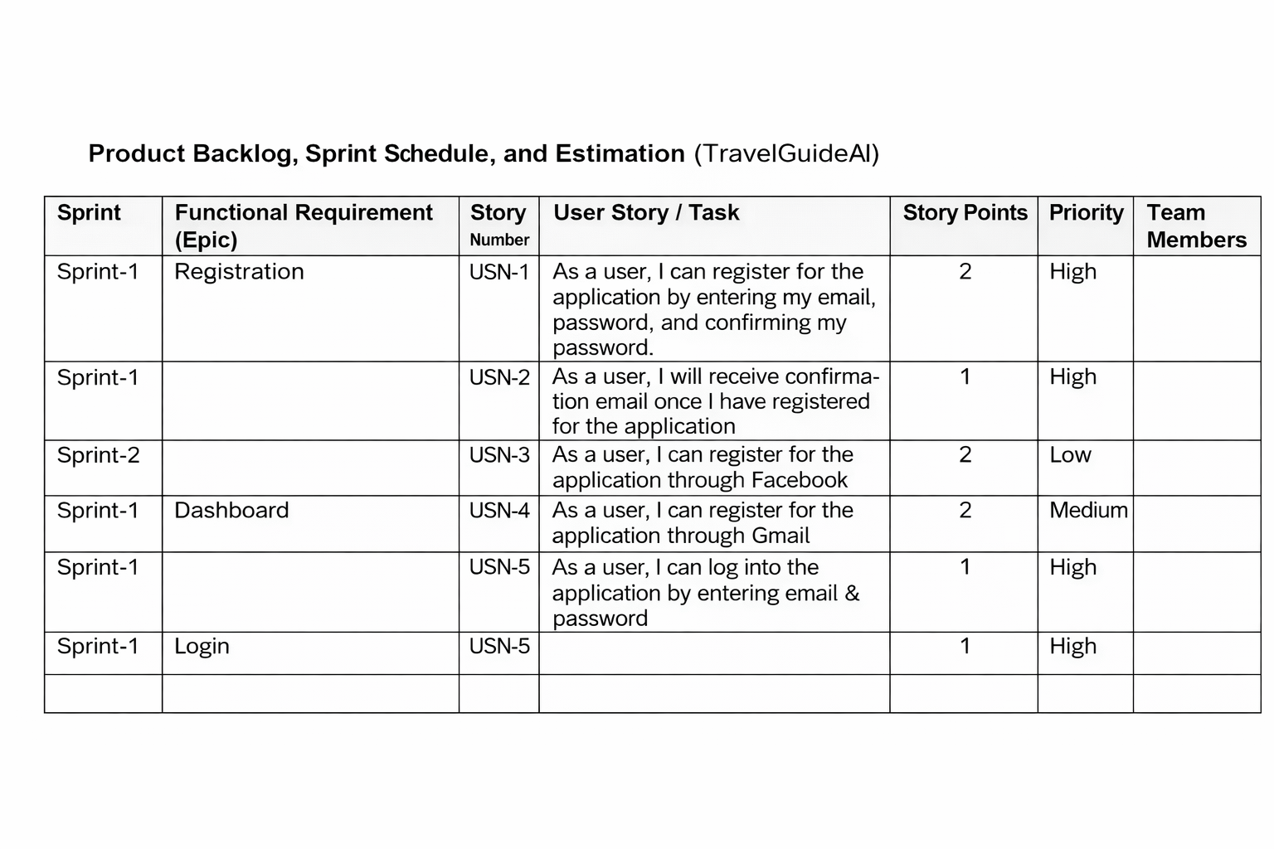

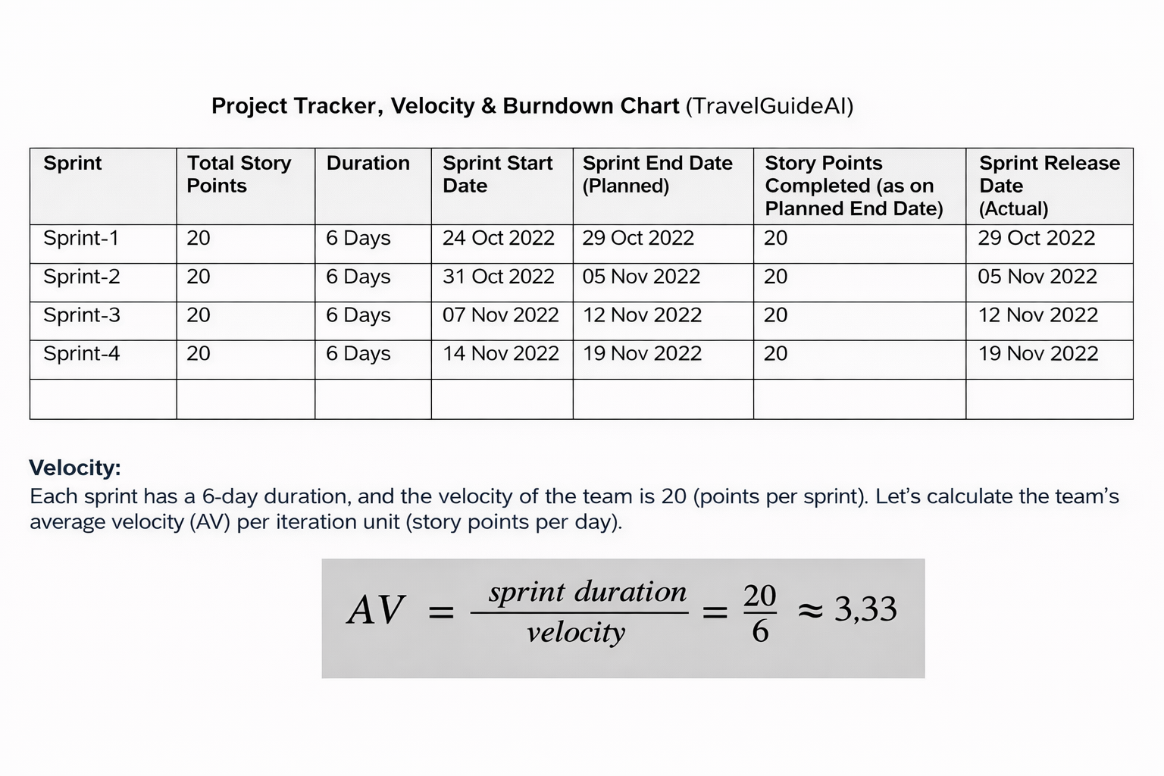

**Burndown Chart:**

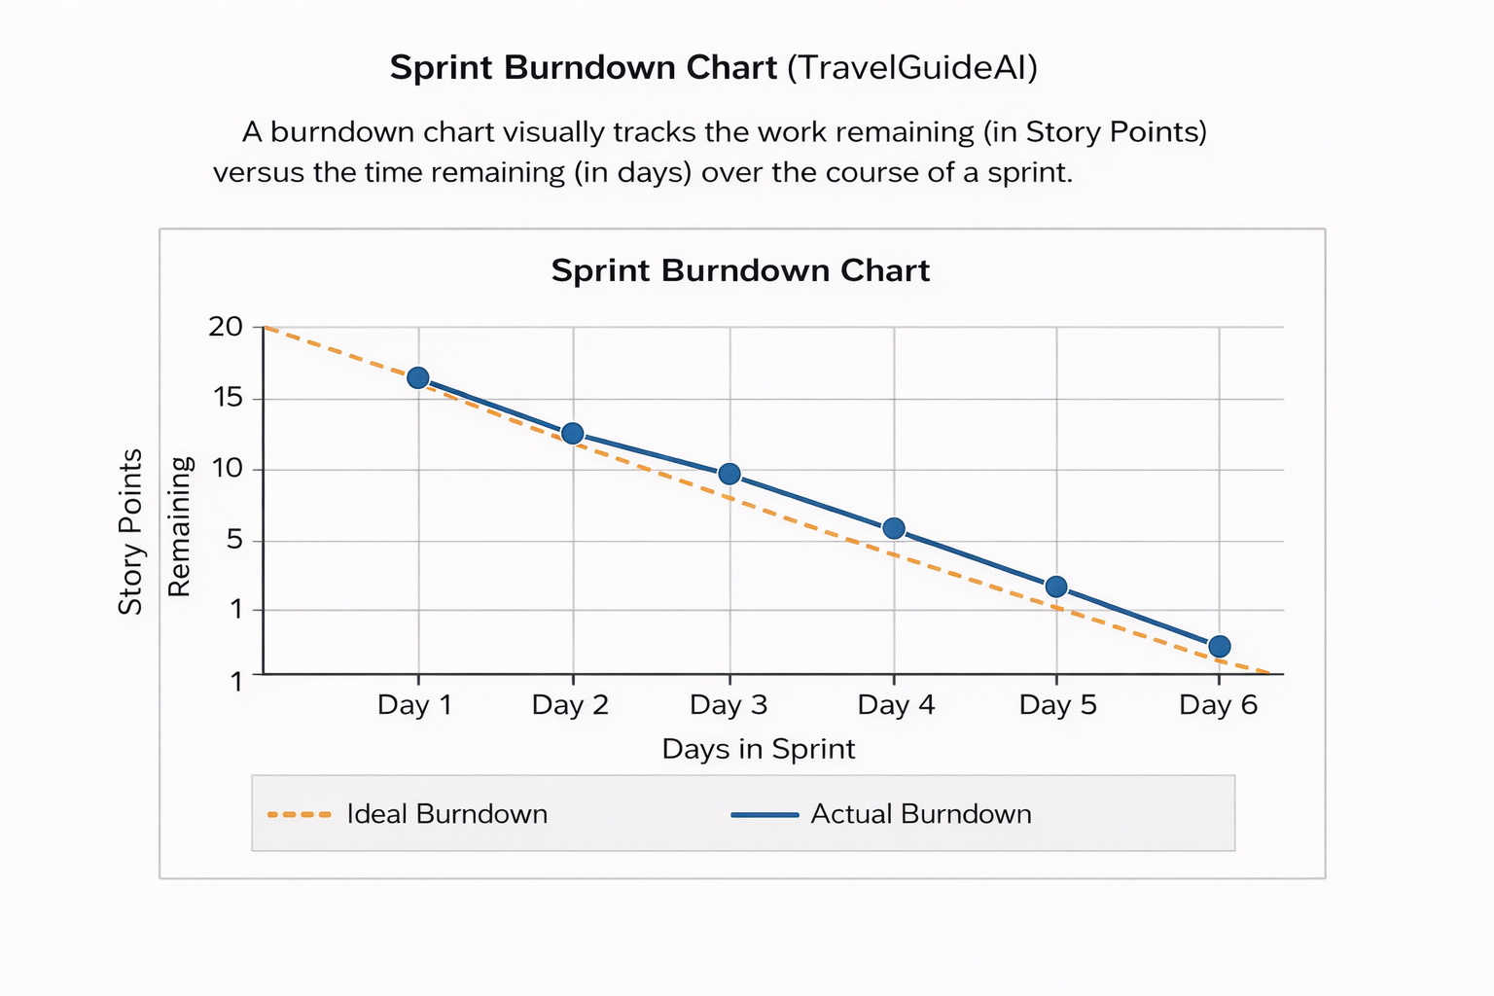

[**https://www.visual-paradigm.com/scrum/scrum-burndown-chart/**](https://www.visual-paradigm.com/scrum/scrum-burndown-chart/)

[**https://www.atlassian.com/agile/tutorials/burndown-charts**](https://www.atlassian.com/agile/tutorials/burndown-charts)

**Reference:**

[**https://www.atlassian.com/agile/project-management**](https://www.atlassian.com/agile/project-management)

[**https://www.atlassian.com/agile/tutorials/how-to-do-scrum-with-jira-software**](https://www.atlassian.com/agile/tutorials/how-to-do-scrum-with-jira-software)

[**https://www.atlassian.com/agile/tutorials/epics**](https://www.atlassian.com/agile/tutorials/epics)

[**https://www.atlassian.com/agile/tutorials/sprints**](https://www.atlassian.com/agile/tutorials/sprints)

[**https://www.atlassian.com/agile/project-management/estimation**](https://www.atlassian.com/agile/project-management/estimation)

[**https://www.atlassian.com/agile/tutorials/burndown-charts**](https://www.atlassian.com/agile/tutorials/burndown-charts)

1. **FUNCTIONAL AND PERFORMANCE TESTING**

# **6.1 Functional & Performance Testing Template**

## 

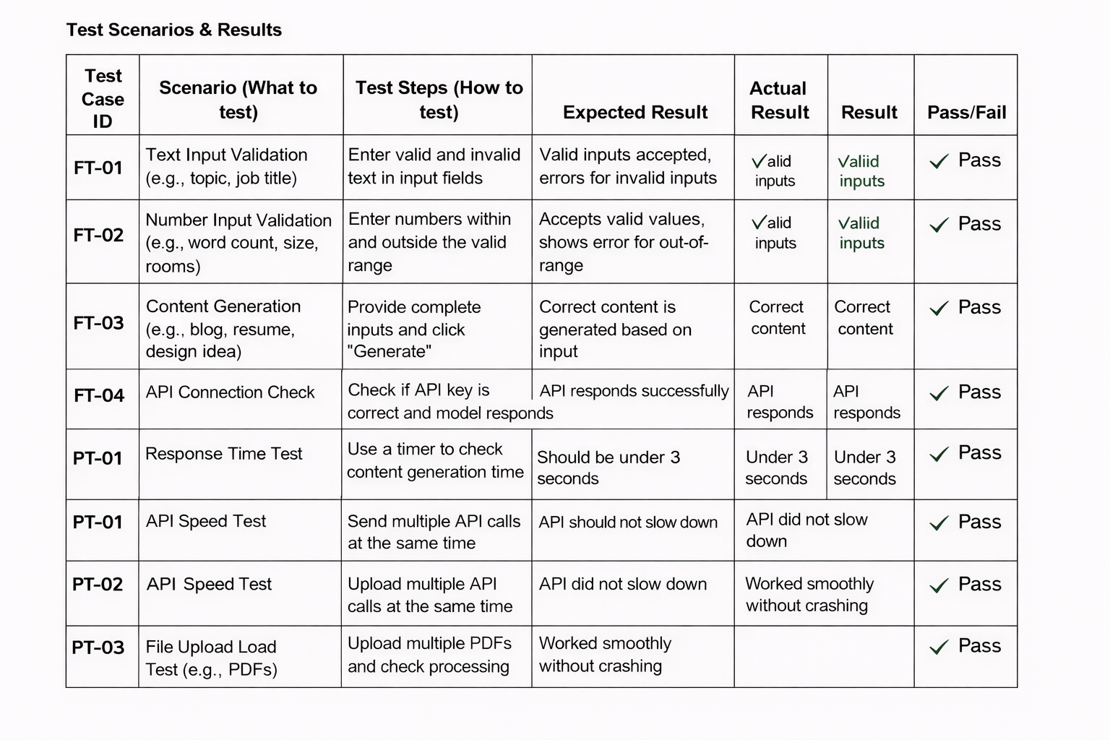

**Acceptance Testing**

**UAT Execution & Report Submission**

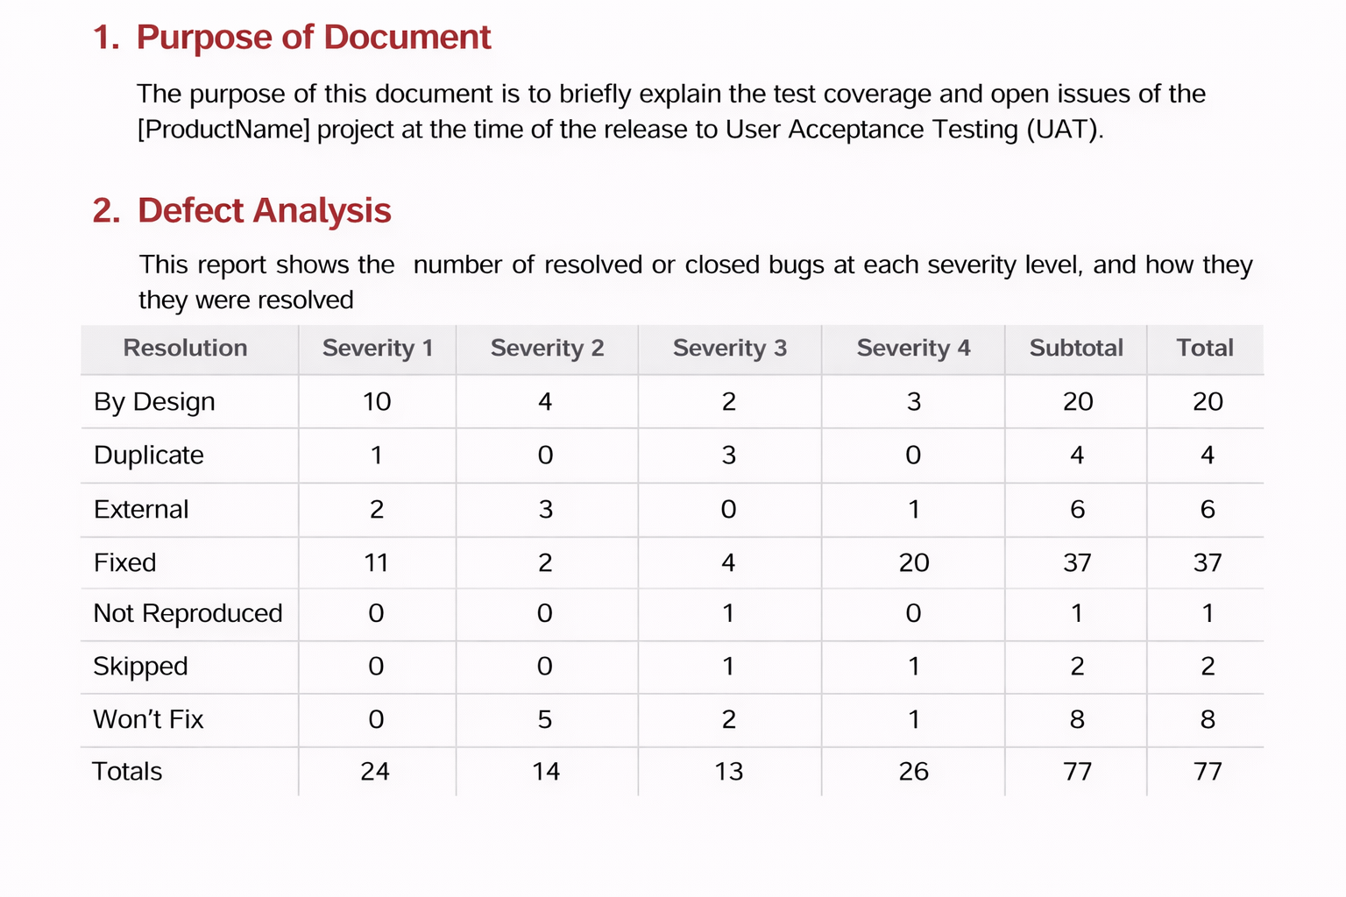

# 3.Test Case Analysis

This report shows the number of test cases that have passed, failed, and untested

|  |  |  |  |  |
| --- | --- | --- | --- | --- |
| **Section** | **Total Cases** | **Not Tested** | **Fail** | **Pass** |
| Print Engine | 7 | 0 | 0 | 7 |
| Client Application | 51 | 0 | 0 | 51 |
| Security | 2 | 0 | 0 | 2 |
| Outsource Shipping | 3 | 0 | 0 | 3 |

|  |  |  |  |  |
| --- | --- | --- | --- | --- |
| Exception Reporting | 9 | 0 | 0 | 9 |
| Final Report Output | 4 | 0 | 0 | 4 |
| Version Control | 2 | 0 | 0 | 2 |

1. **RESULTS**

Output Screenshot:

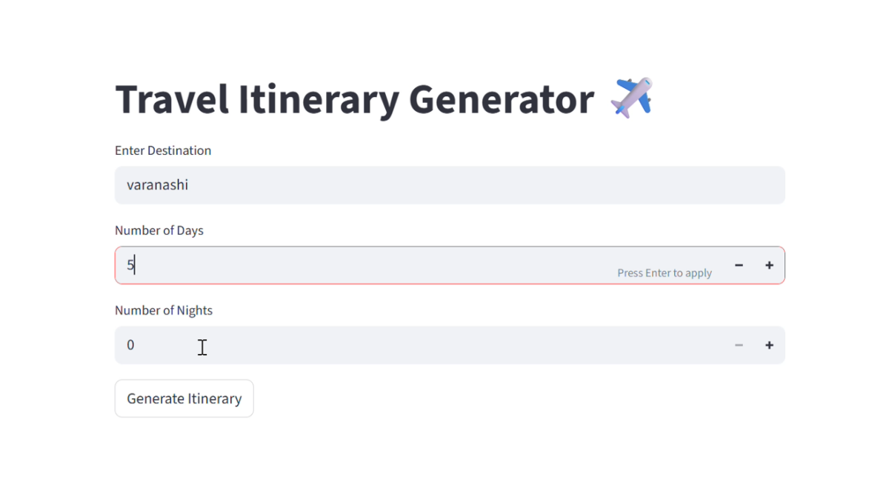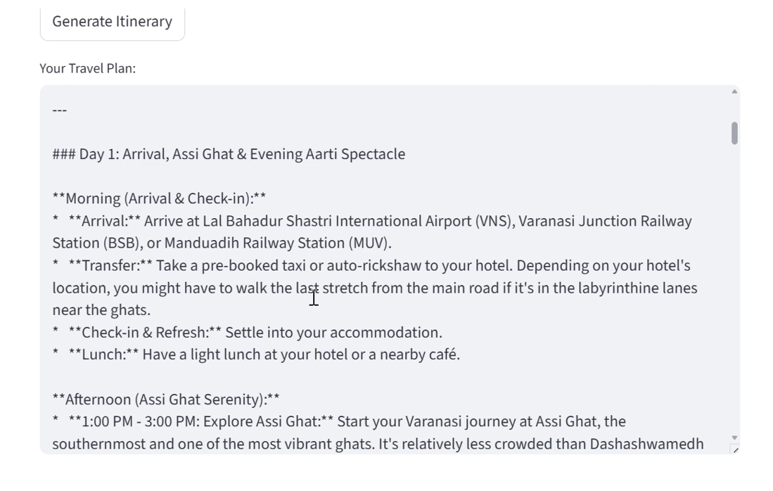

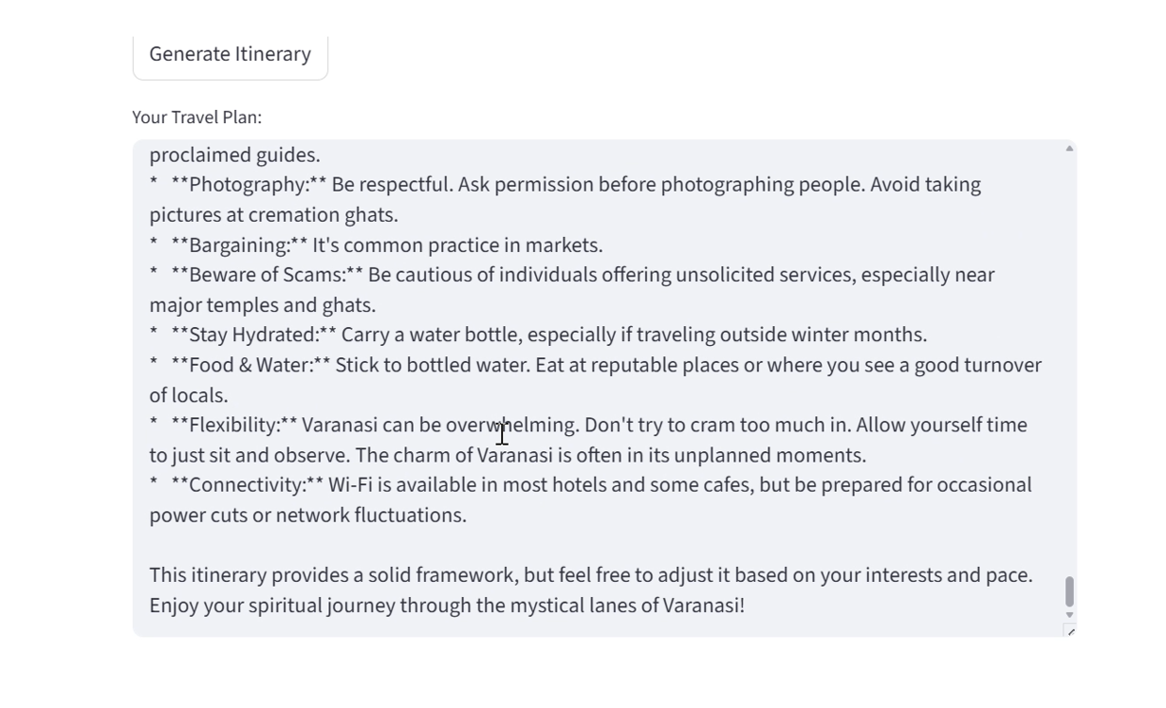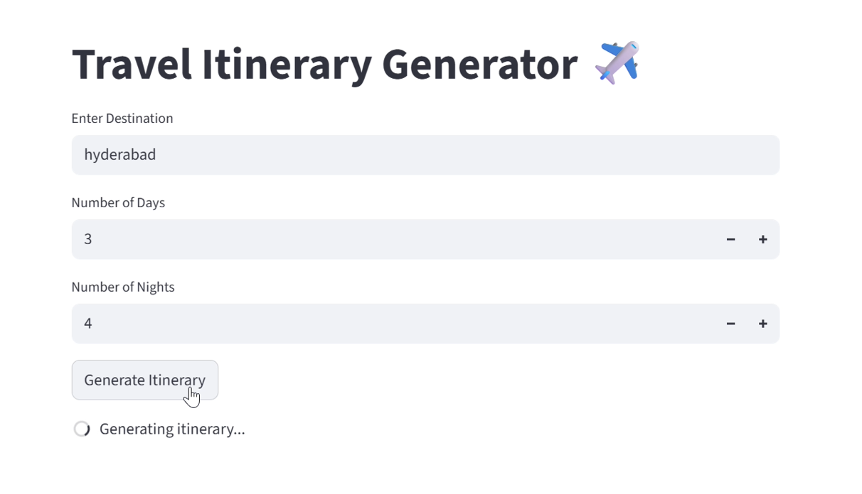

1. **ADVANTAGES & DISADVANTAGES**

**Advantages**

**1. Personalized Trip Planning**

TravelGuideAI generates customized itineraries based on user preferences such as destination, duration, budget, and interests. This ensures each travel plan is unique and relevant.

**2. Time-Saving**

Instead of spending hours researching destinations, hotels, and activities, users receive a complete plan in seconds, significantly reducing planning time.

**3. User-Friendly Interface**

The Streamlit-based interface is simple and intuitive, allowing even non-technical users to generate travel plans easily.

**4. AI-Powered Recommendations**

Using Generative AI (Gemini), the system provides smart suggestions for attractions, food, and daily schedules that feel human-like and creative.

**5. Flexible & Editable Plans**

Users can regenerate or modify itineraries, making the system adaptable to changing needs.

**6. Scalable Solution**

The system can be expanded to include hotel booking, maps, weather integration, and real-time travel updates.

**7. 24/7 Availability**

Unlike human travel agents, the AI system is available anytime, providing instant assistance.

**Disadvantages**

**1. Dependency on API & Internet**

The system requires a stable internet connection and API access. If the API quota is exceeded or the service is down, functionality is affected.

**2. Limited Real-Time Data**

The itinerary may not always reflect real-time changes like weather, traffic, or sudden closures.

**3. Possible AI Inaccuracies**

AI-generated suggestions might sometimes be generic or slightly inaccurate compared to local expert advice.

**4. No Direct Booking Integration**

Currently, users cannot directly book hotels, flights, or tickets through the system.

**5. Cost at Scale**

Heavy usage may incur API costs when scaling beyond free tiers.

**6. Less Human Touch**

Some travelers prefer human travel agents for emotional assurance and deep local insights.

Top of Form

**9.CONCLUSION**

TravelGuideAI demonstrates how Generative AI can significantly transform the way people plan their travel. By combining user inputs such as destination, number of days, and nights with the power of large language models, the system is able to generate structured, personalized, and meaningful travel itineraries within seconds. This project highlights the practical application of AI in solving real-world problems and improving user convenience.

Through this project, we successfully designed and developed an AI-powered itinerary generator using Streamlit for the frontend and Google’s Gemini model for intelligent content generation. The system simplifies travel planning by reducing manual research, offering creative suggestions, and presenting organized day-wise plans. It proves that AI can act as a smart assistant in decision-making and planning tasks.

The development process also provided valuable learning in areas such as API integration, prompt design, user experience design, and AI-based application deployment. Challenges like API limits, model selection, and response handling helped us understand real-world constraints in AI solutions.

Overall, TravelGuideAI serves as a strong foundation for future expansion. With additional features such as real-time data integration, booking systems, maps, and budget optimization, the system can evolve into a complete travel companion. This project not only meets its objective of generating travel itineraries but also showcases the potential of Generative AI in building intelligent, user-centric applications.

In conclusion, TravelGuideAI is a successful implementation of AI-driven travel assistance, demonstrating innovation, practicality, and scalability, while opening opportunities for further enhancement and real-world adoption.

**10.FUTURE SCOPE**

TravelGuideAI has strong potential for enhancement and real-world scalability. While the current version focuses on AI-generated travel itineraries, several advanced features can be integrated to make it a complete smart travel assistant. The future scope of this project includes technical improvements, feature expansion, and real-time service integration.

**1. Real-Time Data Integration**

Future versions can connect to live APIs for:

* Weather forecasts
* Flight and hotel prices
* Local events and festivals
* Traffic and travel time updates

This would allow the itinerary to be dynamic and context-aware.

**2. Booking & Reservation Integration**

The system can be extended to support:

* Hotel booking
* Flight/train reservations
* Cab and local transport booking
* Activity and tour reservations

Users could plan and book their entire trip within one platform.

**3. Personalized Recommendation System**

By using user history and preferences:

* AI can learn favorite destinations, food choices, and budgets
* Provide smarter, repeat-user personalization
* Suggest hidden gems and non-touristy experiences

This would improve user satisfaction and retention.

**4. Budget Optimization Feature**

Future upgrades can include:

* Budget-based itinerary generation
* Cost breakdown per day
* Affordable alternatives for activities and stays

This makes the tool more practical for students and budget travelers.

**5. Multi-Language Support**

Adding multilingual capabilities would:

* Help international users
* Increase accessibility
* Expand global usability

**6. Mobile Application Development**

Developing Android and iOS apps would:

* Improve accessibility
* Provide on-the-go planning
* Enable offline itinerary access

**7. Map & Navigation Integration**

Integration with map services can:

* Show routes between attractions
* Provide navigation support
* Optimize daily travel paths

**8. Voice Assistant Integration**

Users could plan trips using voice commands via:

* Voice chatbots
* Smart assistants
* Hands-free interaction

**9. AI Chat Travel Assistant**

A conversational AI could:

* Answer travel questions
* Suggest places in real-time
* Modify plans instantly

**10. Social & Community Features**

Future versions may allow:

* User reviews and ratings
* Shared itineraries
* Community travel tips

**11. APPENDIX**

Source Code

import streamlit as st

import google.generativeai as genai

# Configure API key

genai.configure(api_key="******************** ")

# Function to generate itinerary

def generate_itinerary(destination, days, nights):

    model = genai.GenerativeModel("gemini-2.5-flash")

    prompt = f"""

    Create a detailed travel itinerary for {destination}

    for {days} days and {nights} nights.

    Include daily activities, attractions, and food suggestions.

    """

    response = model.generate_content(prompt)

    return response.text

# Streamlit UI

st.title("Travel Itinerary Generator ✈️")

destination = st.text_input("Enter Destination")

days = st.number_input("Number of Days", min_value=1)

nights = st.number_input("Number of Nights", min_value=0)

if st.button("Generate Itinerary"):

    if destination.strip() == "":

        st.error("Please enter a destination")

    else:

        with st.spinner("Generating itinerary..."):

            result = generate_itinerary(destination, days, nights)

        st.text_area("Your Travel Plan:", result, height=400)

Github: <https://github.com/BhupatirajuCharishma/TravelGuideAI>

Project Demo : <https://drive.google.com/file/d/1Jl5B_70MoZ2pXpNB4AVxSTHaAgyZqEcN/view?usp=sharing>

Bottom of Form